Tab 1
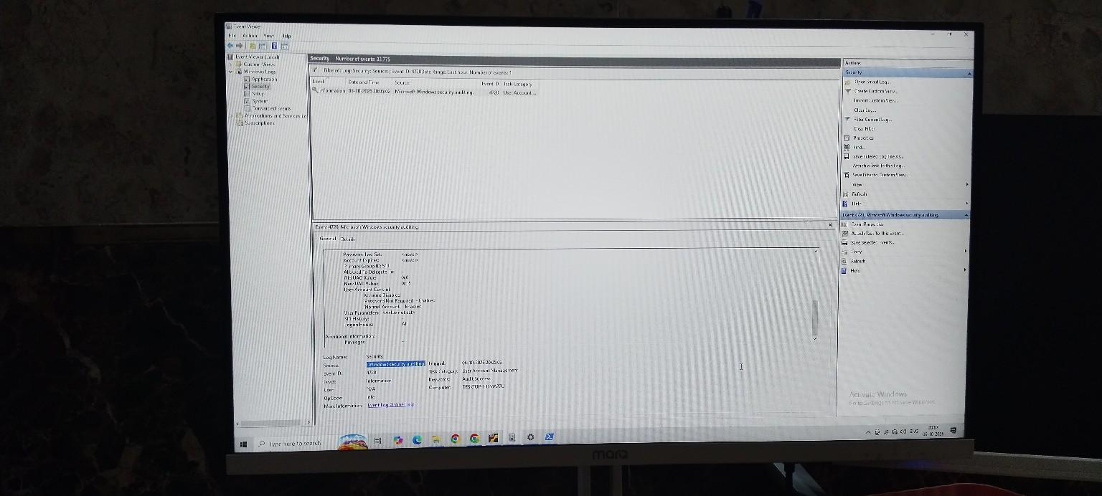

Tab 2


Figure 4 — Event ID 4720: User Account Created
I investigated Event ID 4720 after creating the temporary SOC-Test account for the lab. From a SOC perspective, unexpected account creation can be important because an attacker may create an account for persistence or unauthorized access, so the account and creator should be investigated.

